Functional Requirements

- Customer Registration & Management
  - Register new Customers (firstname, surname, ID, address, phone, employment info when required).
  - Update customer details and view customer profile.
- Account Management
  - Create Accounts of types: SavingsAccount, InvestmentAccount, ChequeAccount.
  - Enforce business rules at account creation:
    - InvestmentAccount requires initial deposit ≥ BWP 500.
    - ChequeAccount requires employment data (employer name + address).
    - SavingsAccount must be deposit-only (no withdrawals).
- Transactions
  - Deposit funds to any deposit-allowed account.
  - Withdraw funds from accounts that allow withdrawals (Investment, Cheque).
  - Record transaction history with timestamp, amount, type (deposit/withdrawal/interest), balance before/after.
- Authentication & Authorization
  - User login (customer or bank staff).
  - Session management for secure operations.
- Interest Processing
  - Monthly interest calculation and posting:
    - InvestmentAccount: 5% monthly.
    - SavingsAccount: 0.05% monthly.
  - Interest posting must generate transaction records.
- Reporting & Audit
  - Provide transaction history per account and per customer.
  - Produce simple reports (monthly interest postings).
- Validation & Business Rules
  - Prevent withdrawals from SavingsAccount.
  - Prevent opening ChequeAccount without employment data.

Non-Functional Requirements
- Security
  - All sensitive data encrypted at rest and in transit.
  - Strong authentication (password policies) and role-based access control for staff vs customers.
- Performance
  - Transaction operations complete within 2 seconds under normal load.
  - Interest batch processing completes within nightly maintenance window.
- Reliability / Availability
  - System availability: 99.5% (or specify per your course).
  - Durable transaction logging to support recovery.
- Usability
  - Simple UI for customers and tellers; common operations (deposit, withdraw, view history) accessible in ≤ 3 clicks.
- Scalability & Maintainability
  - Modular design (clear separation of domain model, services, persistence).
  - Well-documented API and class interfaces for extension.
- Auditability
  - Every transaction must be recorded with who/when/what for compliance.
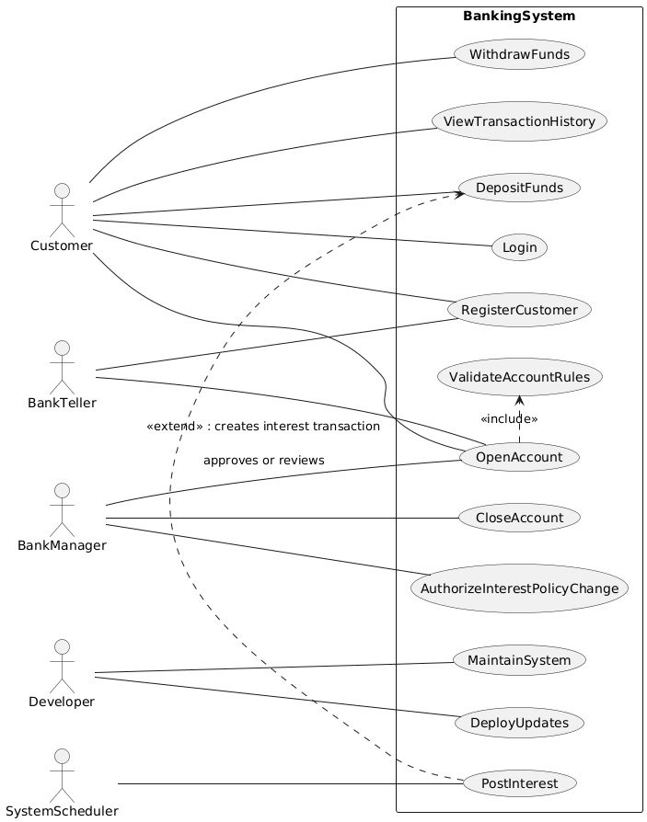

Use-Case diagrams
In the Use-Case diagram:
- actor BankTeller defines the actor role of a bank teller (staff member).
- BankTeller -- (OpenAccount) means that the BankTeller can initiate (or participates in) the OpenAccount use case. In other words, bank tellers are allowed to open accounts in the system.
Together with Customer -- (OpenAccount), this models that both customers and bank tellers have the ability or permission to open an account — depending on business rules. For example:
- A Customer might self-open certain types of account via an automated interface (if rules allow).
- A Bank Teller might open accounts on behalf of customers (especially for special account types, or when extra verification is needed).
So that line BankTeller -- (OpenAccount) positions the BankTeller actor as having access to the functionality of “OpenAccount.”

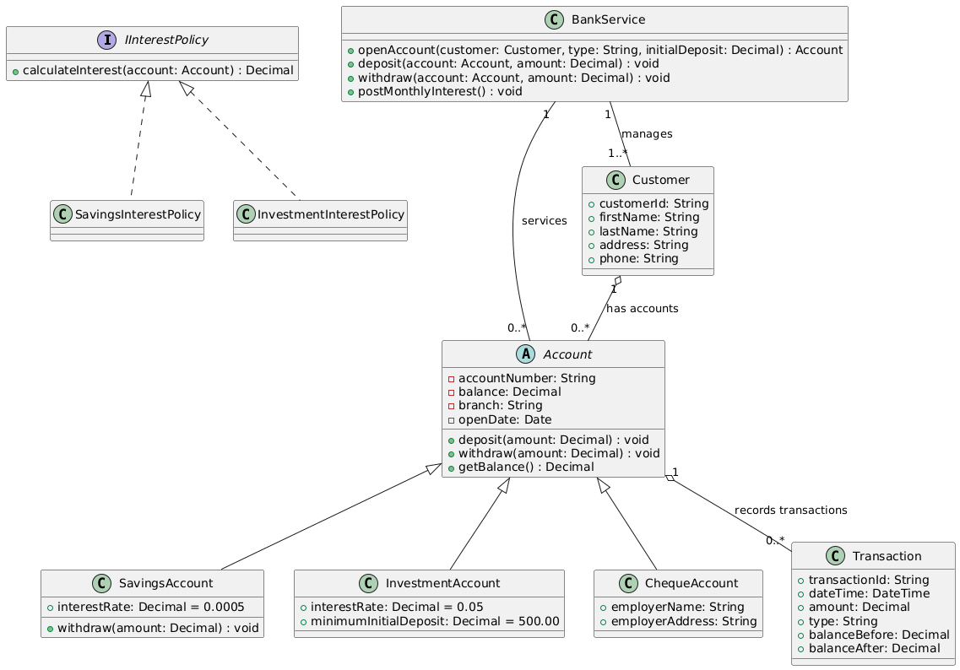
Class Diagram
- Inheritance: SavingsAccount is a subclass of Account. It inherits all attributes and operations from Account (like accountNumber, balance, deposit(...), etc.).
- Special attributes: It has interestRate, with value 0.0005 (which in your problem corresponds to 0.05% monthly interest) — this specifies how much interest this account type gains per month.
- Overriding behavior: The method withdraw(amount: Decimal) is declared here in SavingsAccount. In many designs, this method will override the withdraw(...) method in the Account abstract class to disallow withdrawals (or throw an exception) because by your banking rules, a savings account does not allow withdrawals. So while Account declares a withdraw, SavingsAccount likely overrides it to prevent its use or to enforce special behavior (e.g. always reject or raise error).
So, in short, SavingsAccount specializes Account by providing its own value for interest rate, and by overriding withdraw to enforce the “no withdrawal allowed” policy.

How this fits OO/OOD principles
- Generalization / Inheritance: UML uses inheritance to capture “is-a” relationships. Here, SavingsAccount is an Account.
- Overriding: Subclasses (like SavingsAccount) override methods from the superclass to modify behavior. This is standard OO.
- Abstraction: Because Account is abstract, it defines common attributes/methods, but doesn’t itself implement some behaviors (or allows subclasses to enforce rules).
- Encapsulation: Attributes like balance, accountNumber are hidden (- private), only accessible via methods (deposit, withdraw, getBalance).

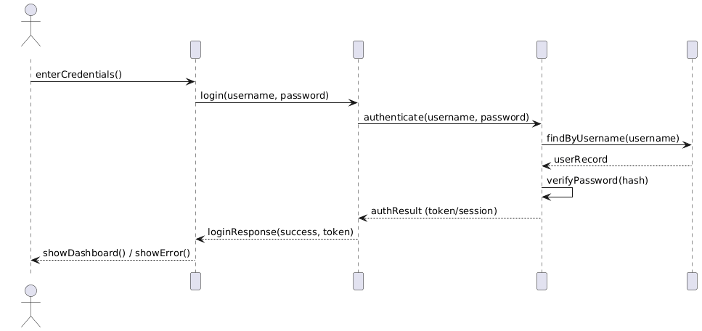Sequence Diagrams

A) Login sequence
Lifelines: CustomerUI → AuthController → AuthService → UserRepository
Flow (short):
- CustomerUI sends login(username,password) to AuthController.
- AuthController calls AuthService.authenticate(...).
- AuthService retrieves user via UserRepository.findByUsername().
- AuthService verifies password (hash compare) and returns token/session.
- AuthController returns success/failure to CustomerUI.

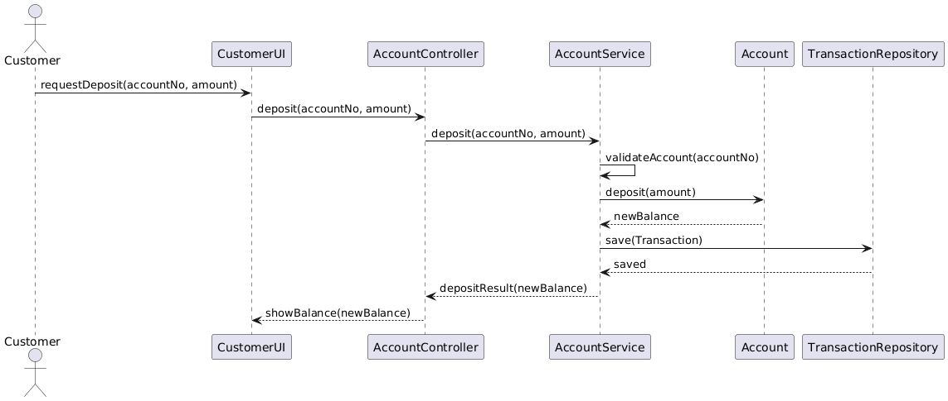Deposit Funds sequence
Lifelines: CustomerUI → AccountController → AccountService → Account → TransactionRepository
Flow (short):
- CustomerUI calls deposit(accountNumber, amount).
- AccountController forwards to AccountService.
- AccountService validates account exists & deposit allowed.
- AccountService calls account.deposit(amount) which updates balance.
- AccountService creates a Transaction record and saves via TransactionRepository.
- AccountService returns updated balance to UI.

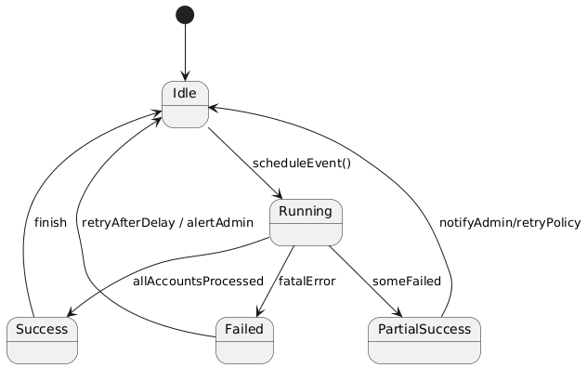State Diagram: PayInterest
Concept: PayInterest is a scheduled job object which can be in states: Idle → Running → (Success | Failed) → Idle (next schedule). Include transitions for retries.
States:
- Idle (waiting for schedule event)
- Running (processing accounts)
- PartialSuccess (some accounts processed, some failed) — optional
- Success (all processed)
- Failed (error, schedule retry or alert)

How this design meets the assignment's OOP requirement
- Interfaces: IInterestPolicy shows use of interfaces; Account could be an abstract class or interface.
- Polymorphism: BankService treats different Account subtypes uniformly (calls deposit/withdraw/generic operations).
- Abstraction: Account abstracts common properties/operations. Controllers/services abstract persistence.
- Inheritance: SavingsAccount, InvestmentAccount, ChequeAccount inherit Account.
- Overriding: SavingsAccount.withdraw() overrides base behavior to forbid withdrawal.
- Overloading: openAccount(customer, type) and openAccount(customer, type, initialDeposit) show method overloading possibilities.
- Encapsulation: Private attributes (balance) exposed via methods (deposit/getBalance), preventing arbitrary external changes.

